Khmelnytskyi University of Management and Law
TEMPUS IV – TRADIR
“Training on Alternative Disputes Resolution”

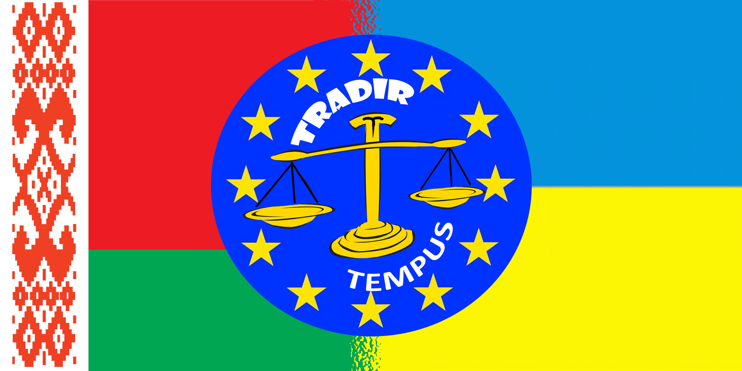

Second Progress Seminar

PROGRAMME

September, 30 – October, 4, 2015

Khmelnytskyi
Ukraine

TEMPUS IV – TRADIR
“Training on Alternative Disputes Resolution”
Khmelnytskyi University of Management and Law
2nd Progress Seminar, (September, 30 – October, 4, 2015)

Date: 30th September – 4th October, 2015
Place: Khmelnytskyi University Organizational Committee Contacts:
of Management and Law Volodymyr Nagnybida +38 067 7518900
8 Heroes of Maidan Str. Roksolana Kemeniash +38 067 9317822
Khmelnytskyi 29000 Oleg Posykaliuk +38 068 7717327
UA, Ukraine Olena Dyminska +38 097 9424296

DAY | EVENT
Wednesday – 30.09.2015 (Day 1) | Check-In  “ENEIDA” Hotel  8 Heroes of Maidan Str.  Khmelnytskyi 29000  Tel.: +38 067 428 3333  +38 0382 718 018  E-mail: reservation@eneida.km.ua
Thursday – 01.10.2015 (Day 2)  9.00–9.30  9.30–11.00  11.00–11.30  11.30–12.30  12.30–13.00  13.00–14-00  14-00–15.00  15.00–15.30  15.30–16.00  16.00–17.00  17.00–17.30 | (8 Heroes of Maidan Str., Room 201)  Welcome reception  (Rector, prof. Oleg Omelchuk)  Presentation of TRADIR teaching materials  (Authors and Co Authors of  the Coursebooks for Master Students)  Discussion  Coffee-Break  Lecture of EU ADR Teacher  “Mediation-Law-court proceedings”  (Prof. Eyk Ueberschär,  University of Potsdam)  Q&A, Discussion  Time for lunch  Lecture of EU ADR Teacher  “Development of mediation in Baltic States”  (Dr. Vigita Vėbraitė, Vilnius University)  Q&A, Discussion  Coffee-Break  Lecture of EU ADR Teacher  “Poland in the new financial perspective of the EU 2014-2020”,  (Dr. Grzegorz Zajac)  Final Discussion
Friday – 02.10.2015 (Day 3)  International Conference and  2nd Progress Seminar (Museum of the University)  9.00–9.30  9.30–10.00  10.00–11.30  11.30–11.45  11.45–12.15  12.15–13.00  13.00–14.00  14.00–14.45  14.45–15.30  15.30–16.00  16.00–16.30  18.00 | PROJECT MONITORING  (8 Heroes of Maidan Str., Room 201)  Meeting with Rector of the University  (Prof. O. Omelchuk)  Presentation of the current project results  (Yu. Mahaneva, D. Slinko, V. Nagnybida)  Meeting and intervieving  (Ukraine Universities` teams:  Kharkiv, Lviv & Khmelnytskyi Universities)  Coffee-Break  Discussing issues, publications, documents  developed within the project  (Yu.Mahaneva, D,Slynko, V. Nagnybida, R. Kemeniash, V. Lutsyk)  Meeting and intervieving coordinator  (Grandholder)  Time for lunch  Meeting with teachers, administrative staff and other representatives of the University  Meeting with TRADIR students  Final discussion  Discussion of the monitoring results  Gala dinner (all participants of the seminar,  monitoring and conference)  “Pivdenna Brama”  1/1 Zhitetskogo, Str., Khmelnitsky  Tel.: +38 067 360 09 09

Saturday – 03.10.2015 (Day 4)  9.00–11.00  11.00–11.30  11.30–13.00  13.00–14.00  14.00–16.00  16.00–17.00 | (8 Heroes of Maidan Str.,  Museum of the University)  1st Discussion: ADR Teaching Methods in EU countries  (EU Teachers and Ukrainian Master Students)  Coffee-Break  2nd Discussion: ADR Teaching Methods in Belarus  (BY Teachers and Ukrainian Master Students)  Time for lunch  3rd Discussion: ADR Teaching Methods in Ukraine  (UA Teachers and Ukrainian Master Students)  Final Discussion
Sunday – 04.10.2015 (Day 5) | Check-out

Docendo discimus

